Lab 09c - Implement Azure Kubernetes Service

Task 1: Registering Microsoft.Kubernetes and Microsoft.KubernetesConfiguration resource

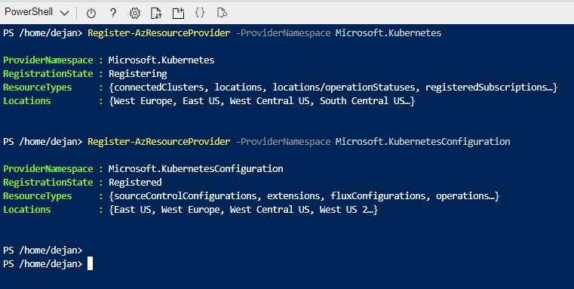

Task 2: Deploying the Azure Kubernetes Service cluster

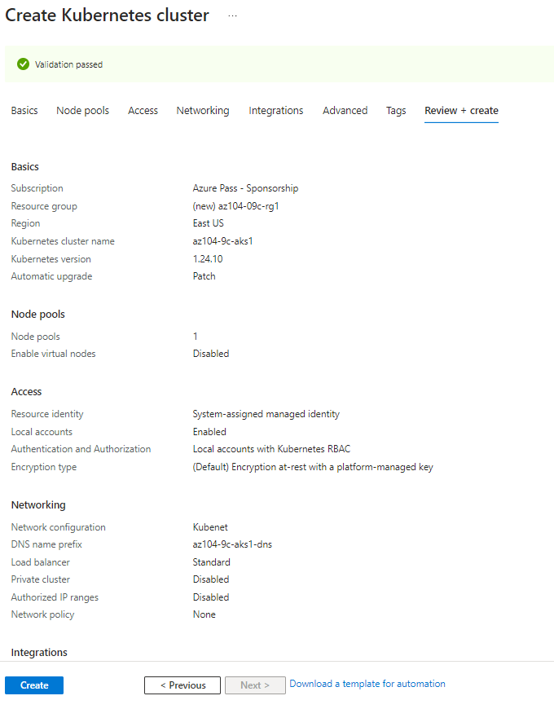

Task 3: Deploying pods into the Azure Kubernetes Service cluster

Created a new node AKS_CLUSTER

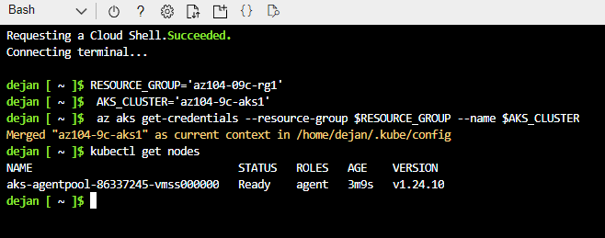

Created a pod nginx and exposed it through port 80 and the load balancer. As we can see the cluster public(external) ip address and what port is using.

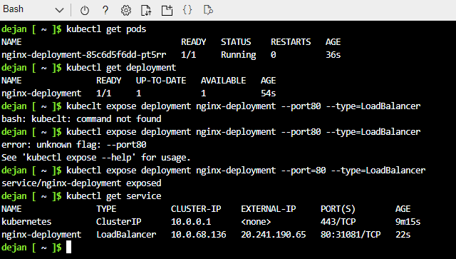

Task 4: Scale containerized workloads in the Azure Kubernetes service cluster

The number of nodes increased and made new 10 replicas and after this we delete the replicas.

